Drug Enforcement Application (DEA) registration guidance

To begin the registration process, start by visiting the Drug Enforcement Application (DEA) website: https://www.deadiversion.usdoj.gov/drugreg/
Select “New Applications”; “DEA Form 225 - Manufacturer, Distributor, Researcher, Canine Handler, Analytical Laboratory, Importer, Exporter”.
Select, “All new applications”. You will be brought to the following page, on which you will select “Form 225, Researcher”:

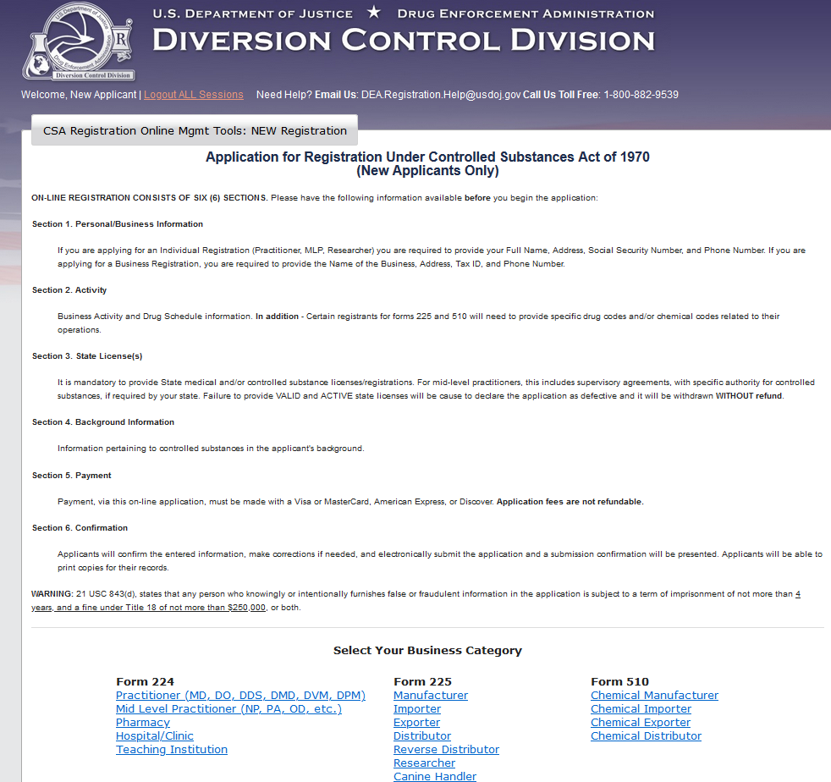
Select, “Researcher (II-V)”: and complete the personal information page: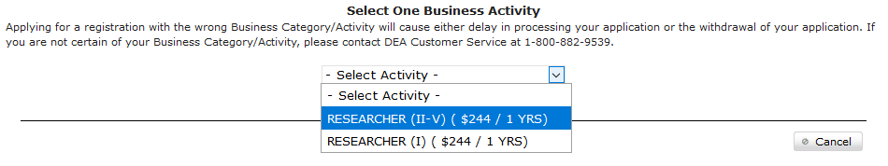
Continue through the form, following the red boxes for prompts:
